|  |
| --- |
|  |
| Requirements Specification (RS) |
| Online Notes and tips Sharing Web Application |

|  |
| --- |
|  |

Requirements Specification (RS)

Document Control

Revision History

|  |  |  |  |  |  |
| --- | --- | --- | --- | --- | --- |
| **Date** | **Version** | **Scope of Activity** | **Prepared** | **Reviewed** | **Approved** |
| 13/06/2017 | 1 | Create | AB | X | X |
| 17/06/2017 | 2 | Update | CD |  |  |

Distribution List

|  |  |  |
| --- | --- | --- |
| **Name** | **Title** | **Version** |
| Eugene McLaughlin | Lecturer |  |
|  |  |  |
|  |  |  |
|  |  |  |
|  |  |  |

# Introduction

This document give you a better understanding of how the layout of a project is regarding the software requirement needed to implement tasks involved in creating the project from the very beginning to the end product. It’s like a road map to your destination without this the project would run out of ideas in the direct that is needed to finish all application. It’s a clear blueprint to success.

## Purpose

As being a student sometime its very hard to find good material of studies online because of too much information overload on the internet. Its very hard to get proper and specific information related to our subject. The purpose of this web application to share a good studies material found from internet or books and share with other students so they can get benefit from it. In this way one’s hard work could save a lot of time of others.

As this application will be layout and displayed on the base of rating by other users. So it will be easier to find good, high quality material on the top. The Author of the notes will be rated as standard, moderate or expert depends on rating they got from their notes by other users.

## Project Scope

The scope of this project is to develop a web application which allows users to view educational notes, tips and code snippets. Users can register themselves to make their own private or public content in the application. Users can rate others users notes and study tips so that users and students can get benefit from high rated content.

This application could be beneficial for almost everybody, because tips for anything can be shared. From household DIY tips to cooking recipes and study notes.

Other registered users can view, comment, rate and share on social media any note or tip from web application. Owner of the content can create, update and delete their own content only.

# User Requirements Definition

The user requirements are the step by step approach to understanding what is require within the application, just as if you were using an app on your phone there are different sections within the application, whether it’s going from the sign in screen to the home screen and going to different screens within the application. We must plan the requirements to enter into the responsive web application were we make it easy to use and friendly for all ages giving of any but also meets their needs.

# Requirements Specification

This gives you a detailed specification of all the different components within each use case. In doing this it gives the user the better understanding of how each component works within the layout of the screen. This helps both the developer and consumers to understand how it works in the design element of each requirement specification within the use case. By the way of testing the components before entering the market it is tested for errors.

## Functional requirements

The functional requirements is a guide to how your application work in regards to the software system whether certain functionality within the system works for example sign in or going to different screens went you click a button or enter some information into the screen and submit it, all these different aspects must be fully functional before it goes live. The registration and the sign in are the most important function requires for the application otherwise the user can’t avail of the application and becomes useless.

### Use Case Diagram

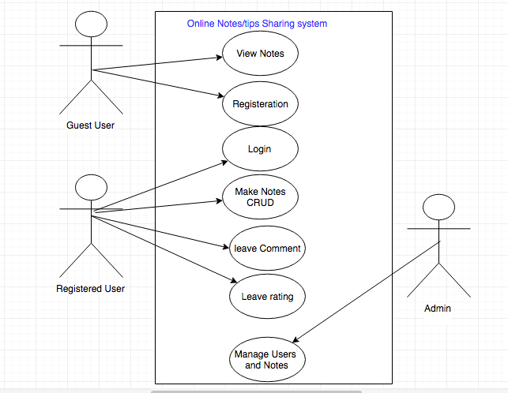

Non-register or guest users can use application to just view public notes and tips. They cannot interact with application at all except to register.

To interact with system users must need to register and login

### Requirement 1: “User Login”

#### Description & Priority

The User will need to have an account to access the website so they can use it. They must enter their own personal unique identifier by the way of a username and password to account their own account. If they are a first time user they must create an account by the way of filling out an online registration form and once this is done. They are asked to sign in like all existing users.

#### Use Case

#### ../../../../../Desktop/Screen%20Shot%202017-06-17%20at%2022

**Scope**

The scope of this use case is to allow the user to enter their account on the application

**Description**

This use case describes the correct procedure of how enter their own account by the way of set of instructions to be followed and if the procedure is incorrect. The user has option to reset their details to gain access to the account.

**Flow Description**

**Precondition**

The system is idle

**Activation**

This use case starts when a user clicks on the website

**Main flow**

1. The User enters the URL in to the browser.
2. The User click the enter button.
3. The System returns with the Home Screen of the application**.<A1>**
4. The User then clicks on the Sign in button.
5. The System returns the Sign in Screen.
6. The User must enter the sign in details.
7. The User clicks the Submit Button.
8. The System verifies the details**.<E1,E2>**
9. The System allows access to the user account of the application.

**Alternate flow**

A1: **The User Register a new Account**

1. The new User clicks on the registration button of their choice.
2. The system returns the registration screen.
3. The User must enter personal details on the online form.
4. The User enters personal details.
5. The User then clicks the submit button.
6. The System stores the information.
7. Users will get link in email to verify account and users must verify it before login.
8. The System returns a message for the user to sign in.
9. The User clicks on to the Sign in screen.
10. The User enters the personal details.
11. The system response with access to the users account.

**Exceptional flow**

E1: **Incorrect User Sign in Details**

1. The user enter in the email address and password
2. The system returns with incorrect details
3. The system asks the user to re-enter password
4. The system gives you 3 attempts to re-enter password
5. The system allow access if correct password gain entry.
6. The system will locks out if unsuccessful **<E2>**

E2: **Reset User Sign in Details**

1. The user must click the reset password button on the log-in screen.
2. The system asks for an email address.
3. The user enters email address.
4. The user clicks the submit button.
5. The system sends an email with a link to reset password.
6. The user clicks on the web page link.
7. The system shows the screen to reset the password.
8. The user enters new password.
9. The user clicks the submit button.
10. The system returns the user to the log-in of the main flow.

**Termination**

The application terminates when the user signs out.

**Post condition**

The system goes into a wait state.

### Performance/Response time requirement

The latest technology will be used to give excellent performance and response times with the speed of high quality broadband speeds available

### Availability requirement

The availability depends on the access of a personal computer, laptop, tablet or smart phone but also the availability of the internet system working in your area at the time of trying to access the application

### Recover requirement

The system will have a backup system that if anything happen to the system it automatic reboot to that system, so that the user cannot lose an important information if the system crashes.

### Security requirement

The system will use the latest security software available regarding identification and authentication system the create the user to registration by using personal identification and a unique password

### Reliability requirement

The system reliability will depend on the latest broadband speeds available at the time the system is being used.

### Maintainability requirement

The system will be kept updated with the latest software system updates by the system administrator regarding the latest technology on the market at the time.

### Portability requirement

The requirement is to make this a responsive web application so that this application can be used anywhere and at any time with a laptop, tablet and smartphone.

# System Evolution

This web application will be used globally for all types of users like students, home users, chefs, developers, designers. It will provide tips and tricks for every type of person. This application can be extended for adding more and more categories in it. So that majority of people can share their ideas, tips and code snippets to benefits others.